12. Remarks for users of previous autoISF versions V 3.2

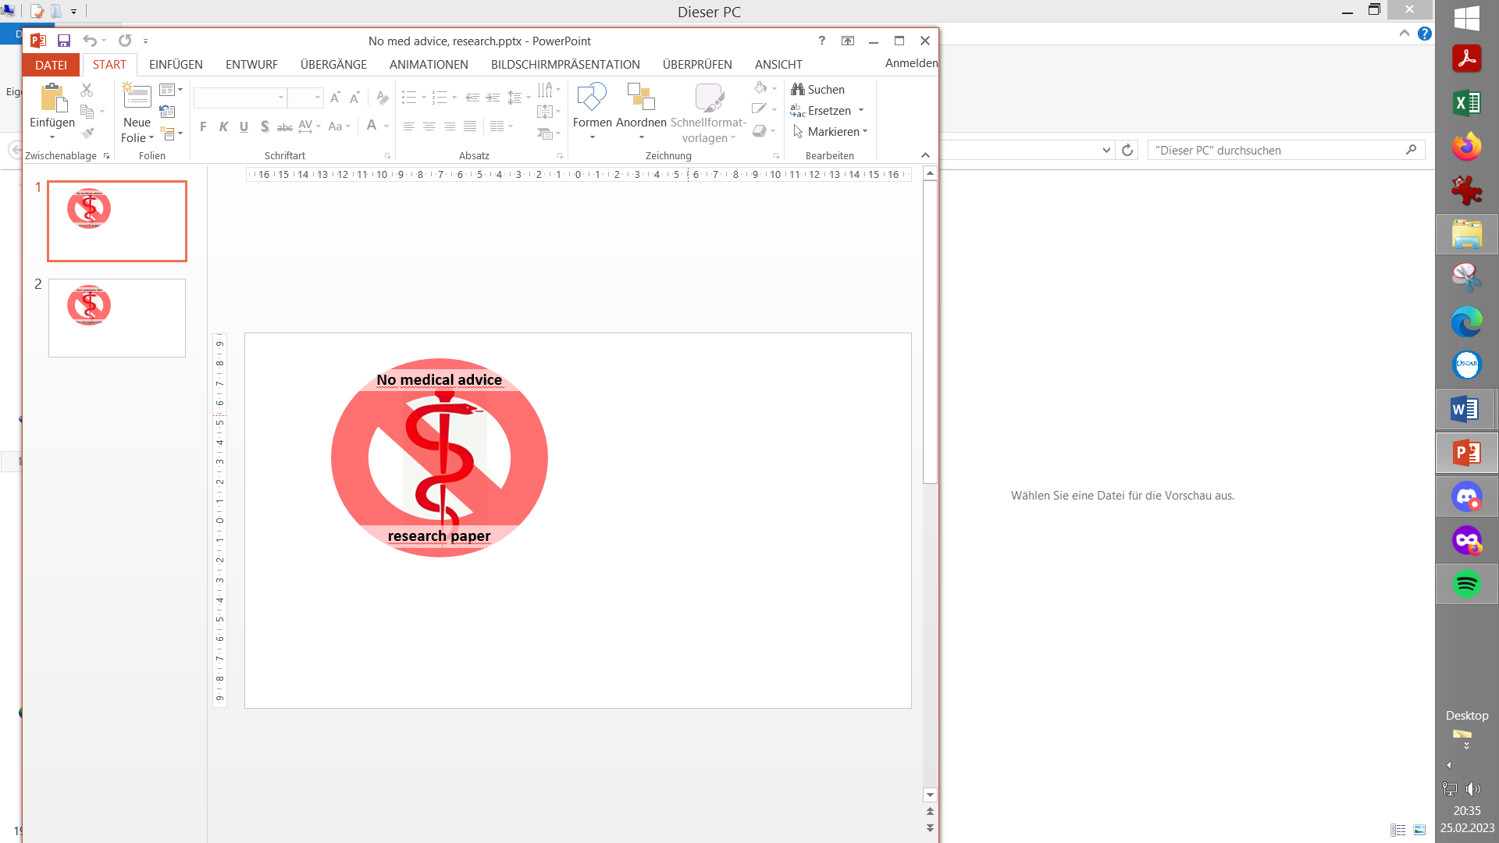
Please note that with autoISF you are in an early-dev. environment, where the user interface is not optimized for safety of users who stray away from intended ways to use. Good safety features exist, but these are only as good as the development-oriented user understands and implements them. This is not a medical product, refer to disclaimer in section 0

12.1 Main innovations in autoISF 3.2.0

Currently (July 2026) we are in a transition phase where the main AAPS is upgraded to version 3.4., with major redesigns. At the same time there were some pod-related problems that got resolved.
So, we are working on getting autoISF upgraded and integrated, as well.
See the current status here: https://github.com/ga-zelle/autoISF/blob/A3.4.0.0_ai3.2.0/Features%20only%20available%20in%20this%20stand-alone.md and, specifically, the latest autoISF 2.0 guide here: https://github.com/ga-zelle/autoISF/blob/A3.4.0.0_ai3.2.0/autoISF3.2.0_Quick_Guide.pdf
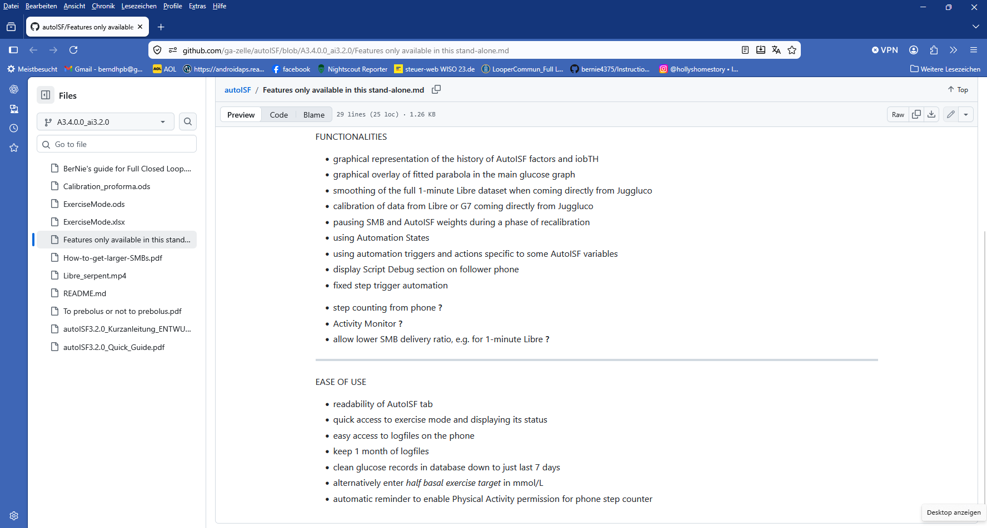

12.2 Main innovations in (previous) autoISF 3.1.0

Except for things relating to 1-minute Libre readings, the main point of migrating from the previous AAPS 3.2.0.4+autoISF 3.0.1 to the current newest AAPS 3.3 3.a+autoISF3.1.0 was really to update autoISF to the changes done in AAPS Master.
For instance, there is an extra AUTO ISF tab now, instead having different SMB tab designs depending on selected modes.
The FCL e-Book needed only very minor adaptations. Changes in autoISF are sketched below, more see in autoISF Quick Guide @ Github/ga-zelle/autoISF.
From there:
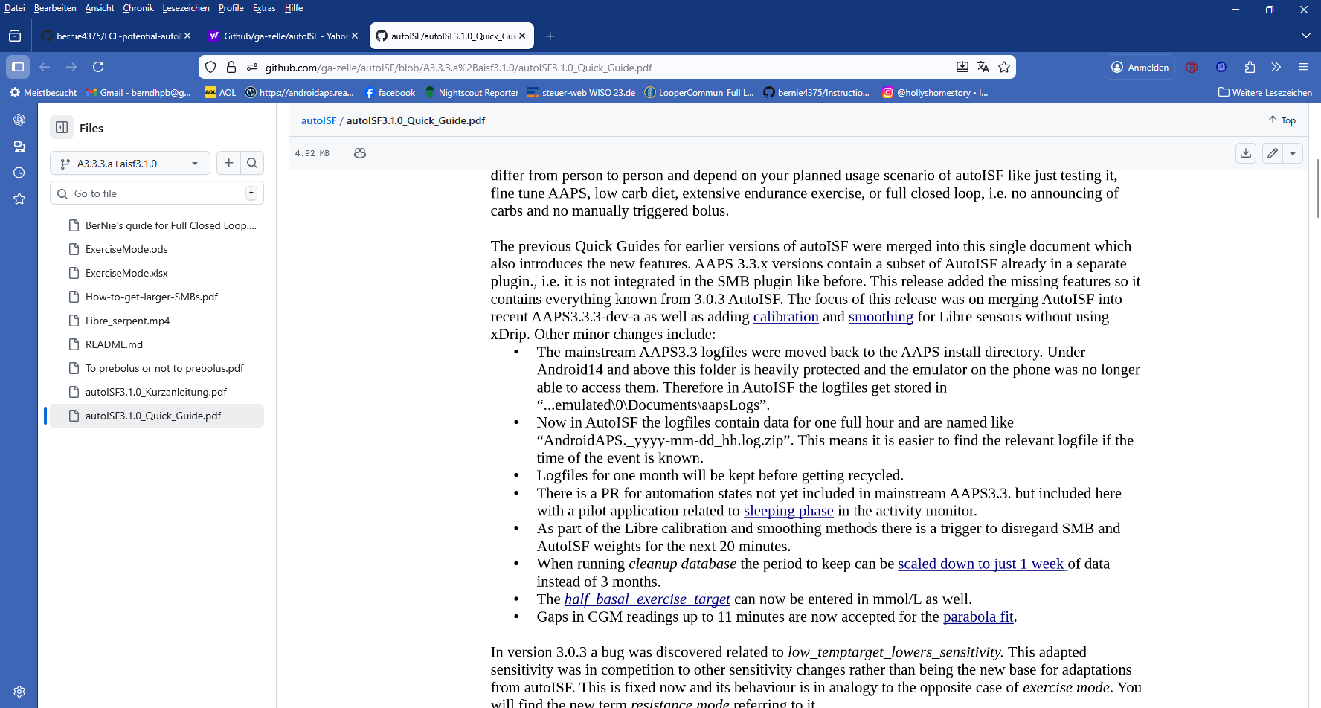

Main innovations in (previous) autoISF 3.0.1

- Integration of Libre3 in 1-minute mode
- Cancellation of some parameters and options (none of which were recommended to use in past FCL guidance documents):
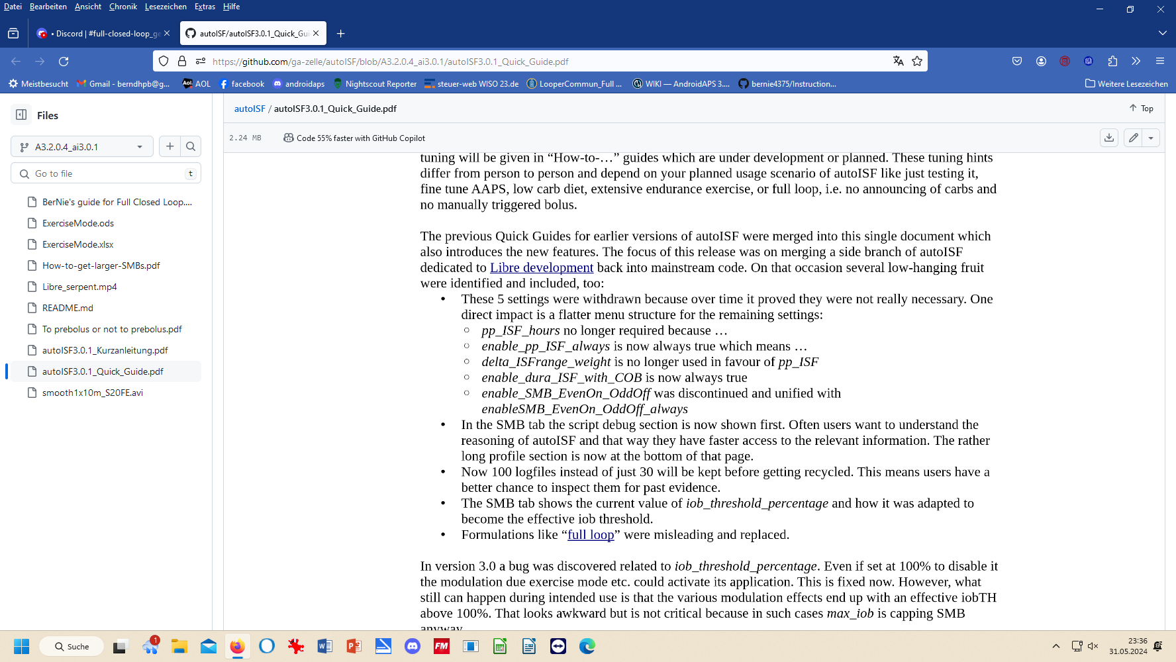
- About 3 times as many logfiles can be stored in the phone, making copying zip files into your PC less often necessary
- Clearer structure of the autoISF tab
  - now with all autoISF effects detailed on top page
  - iobTH declared
  - language clearer:
- 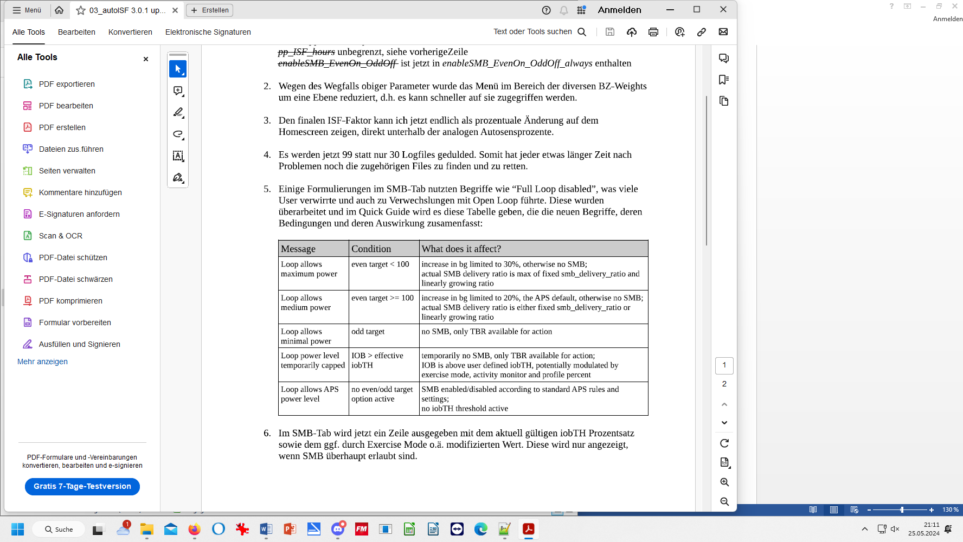
- AAPS home screen on smartphone now shows autoISF result (sens/profile.sens = amplication factor on the profile_ISF) underneath the Autosens %
- Note: More features for autoISF 2.0 and later. The above section will be updated. Meanwhile refer to the Quick Guide: https://github.com/ga-zelle/autoISF/blob/A3.4.0.0_ai3.2.0/autoISF3.2.0_Quick_Guide.pdf

12.3 Implications regarding your previous FCL settings

Please refer to autoISF Quick Guide (link given in section 12.1) regarding changes in the newest autoISF version.
Please refer to AAPS readthedocs regarding the important changes in the migration to the newest AAPS version.

